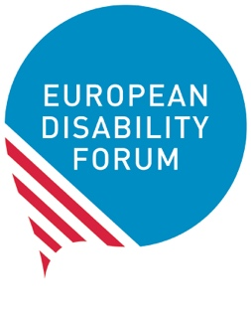
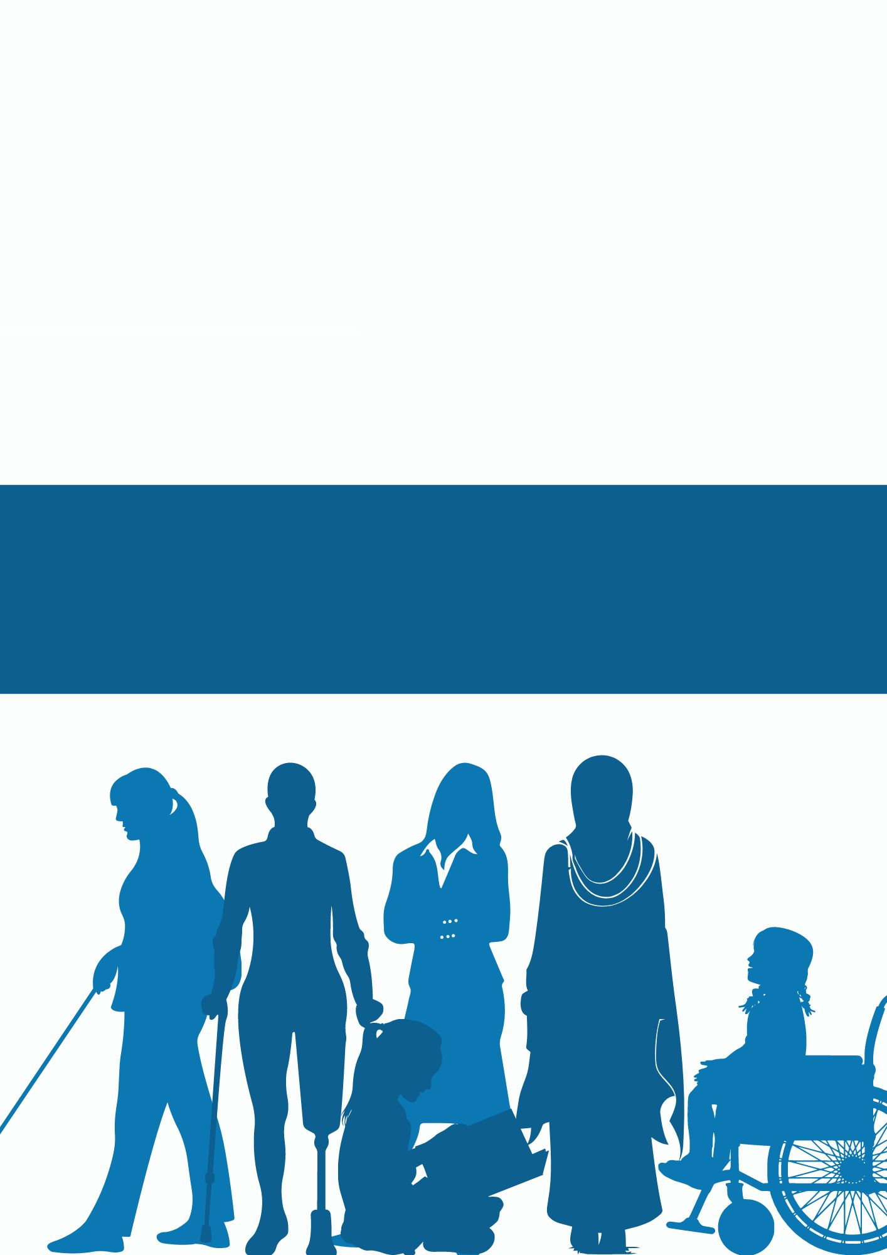
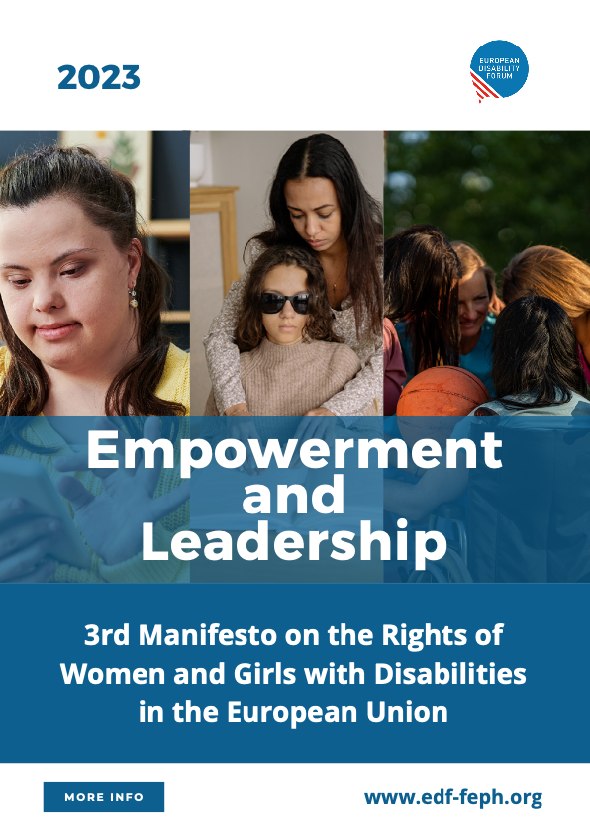

Third Manifesto on the
Rights of Women and Girls with Disabilities
in the European Union
2023

Empowerment
and Leadership
Contents
Introduction 3
The journey so far 6
- Violence against women and girls with disabilities 7
- COVID-19 pandemic 8
- Climate change 9
- Economic crisis and poverty 9
- Situations of armed conflict 10
Empowerment 11
- Discrimination and inequality 12
- Accessibility 13
- Inclusion in the field of gender equality 14
- Awareness-raising 14
- Equal recognition before the law 14
- Independent living and inclusion in the community 15
- Health and rehabilitation 15
- Inclusive education 16
- Data gathering and research 17
Leadership 18
- Bodily autonomy 19
- Access to justice 19
- Reproductive rights and right to family life 20
- Work and employment 20
- Civil and political participation 21
- Governance and organisations of women with disabilities 22
The needed future 23

Introduction
Since adopting the 2nd Manifesto on the Rights of Women and Girls with Disabilities in the EU, the world has been confronted with major challenges, including the COVID-19 pandemic, armed conflicts, and the impacts of climate change. Empowering women and girls with disabilities and developing their leadership abilities is key to protecting their human rights.
Women and girls with disabilities constitute 25.9% of the total population of women in the European Union (EU) and around 60% of the overall population of 100 million persons with disabilities in Europe. As stated by the United Nations Committee on the Rights of Persons with Disabilities, women with disabilities are not a homogeneous group. They include indigenous women; refugee, migrant, asylum-seeking and internally displaced women; women in detention (hospitals, residential institutions, juvenile or correctional facilities and prisons); women living in poverty; women from different ethnic, religious and racial backgrounds; women with multiple disabilities and high levels of support; women with albinism; and lesbian, bisexual and transgender women, as well as intersex persons. The diversity of women with disabilities also includes all types of disabilities.
Women with disabilities in all their diversity must not only be treated as victims of crises, but as leaders and changemakers. They need to be able to advocate for their rights effectively and address their societal needs. By using lessons learnt from the challenges we have faced and continue to face, actors must ensure the experiences of women and girls with disabilities are taken into account. Successful leadership for women with disabilities can ensure quality education, inclusive workplaces, and more equal and inclusive societies.
In 2011, EDF’s 2nd Manifesto was published in the context of the adoption of the United Nations Convention on the Rights of Persons with Disabilities (CRPD). It was an interpretation of the human rights of women and girls with disabilities in the European Union. It was grounded in their fundamental rights, including equality and non-discrimination, awareness raising, social inclusion and accessibility. It was a depiction of the Convention through the lens of women and girls with disabilities.
Ten years later, we find that the situation of women and girls with disabilities has not advanced as we had hoped. In developing this new Manifesto, we reached out to women with disabilities in Europe to learn about their reality. We were overwhelmed by their response –almost 500 women with disabilities from 33 countries answered our survey:
- 79% of the participants were women with disabilities.
- 26% of the participants were mothers of children with disabilities.
- 58% of the participants have experienced at least one form of violence.
- 77% of women with disabilities and mothers of children with disabilities need to use regular health services in regard to their disabilities.
We call on the wider disability movement, the wider human rights movement, policymakers and decision-makers to listen to us!
This Manifesto is meant to show an improved narrative of the leadership abilities of women and girls with disabilities. Empowerment is at its centre.
For the purpose of the current document, the term leadership is not limited to the technical meaning of undertaking official leading positions. Leadership enables everybody to lead their lives the way they want. Women and girls with disabilities as students, mothers, employees, and, in general, as members of society should be able to lead their lives independently.
At this crucial time, when the European Union is getting ready for the European Elections in 2024, this Manifesto aims to emancipate women and girls with disabilities and ensure their active participation to build an inclusive future. It should be guaranteed that women with disabilities benefit equally from “the right to vote and the right to stand as candidates in European elections, regardless of legal capacity status, and EU country of residence”.
This document is for all women and girls with disabilities, organisations of people with disabilities, activists, policymakers, professionals, and all organisations and bodies concerned about equal rights and opportunities for women and girls with disabilities in society.

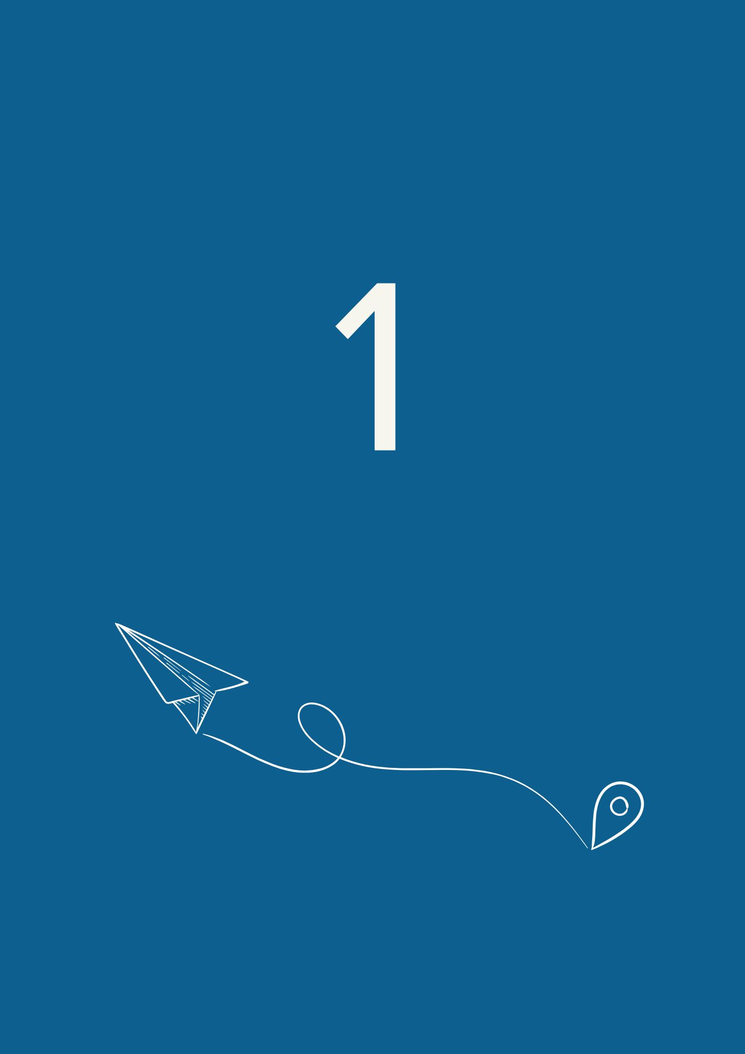

The journey so far
We, women with disabilities, declare that the crises of recent years have broadly impacted our lives. This negative impact has been compounded by the lack of inclusive responses by States, which have endangered our basic human rights, including the right to equality, life, accessing justice, and liberty and security, among others.
We declare that only our active participation in rebuilding societies can properly fulfil our human rights and our needs.
We declare that, to eliminate the disproportionate impacts of intersectional discrimination, women and girls with disabilities must take the lead in efforts to uphold their human rights.
We declare that only the full implementation of equal rights for women and girls with disabilities can ensure a just transition from inequalities and injustices.

Violence against women and girls with disabilities
Women and girls with disabilities are still at a higher risk of violence, including human trafficking, during humanitarian crises, and the effects of natural disasters and climate change.
We stress that the rate of violence against women and girls with disabilities is concerningly higher than violence towards men or women without disabilities. Furthermore, specific types of violence happen to women and girls with disabilities solely because of their intersecting marginalised identities. Sometimes gender-based violence is at the root causes of disability.
Over 60% of the survey participants have experienced at least one form of violence based on their intersectional identities as women with disabilities.
It is often more severe in form, repetitive in action, and lengthier in time. It creates long-lasting and often irreversible impact. Furthermore, society is less likely to act to protect women and girls with disabilities from violence. There are also concerns about violence, including sexual violence, taking place within the family.
We want to highlight some important issues:
- Women and girls with disabilities are significantly targeted by various forms of psychological violence, including bullying, harassment, gaslighting, isolation, negligence, abusive control, and verbal aggression. According to the survey, 56% of the participants have experienced psychological violence at home, at school, at work, and in public places. Physical and sexual violence also occur frequently against women and girls with disabilities, with intellectual disabilities being more exposed to certain types of violence than others.
- Forced sterilisation is one of the harmful practices that targets women and girls with disabilities the most, specifically those with intellectual and psychosocial disabilities. It is often directly connected with institutionalisation and measures of deprivation of liberty and legal capacity, such as guardianship. It is ongoing and widespread and often occurs behind closed doors in a secretive environment.
- Medical control through coercion and forced treatment is still exerted over many women and girls with disabilities, specifically those living in residential and psychiatric institutions. They might receive high doses of medicine with the purpose of keeping them passive and docile. Also, their sexual and reproductive rights might be controlled without their knowledge or consent through unwanted methods of contraception.

COVID-19 pandemic
COVID-19 has been a real threat to the lives of women and girls with disabilities. It was reported that women with disabilities were more at risk of dying from COVID-19 than women without disabilities.
46% of the COVID-19 deaths were made up of people in institutions, and there has been a lack of support from EU Recovery funds directed specifically at women and girls with disabilities.
We stress that the years of the pandemic have left women and girls with disabilities at higher risk of isolation, lack of access to health and reproductive services, and gender-based violence.
We stress that many women with disabilities became unemployed because of the lack of adaptability to remote working.

Climate change
We stress that climate change – including heatwaves, droughts, floods and harsher cold seasons – is negatively affecting women with disabilities and increasing their vulnerability to other socio-economic factors such as food security, health, water sanitation and hygiene, and social stability.
We stress that women with disabilities do not have proper access to advocacy and decision-making processes regarding climate change. Barriers include negative stereotypes and lack of accessibility of information, infrastructure, and disaster risk management. In addition, there is often a lack of awareness of the impacts of climate change on women and girls with disabilities.
We stress that women with disabilities are left behind in climate change mitigation and adaptation decisions. It is necessary to pave the path for their engagement in all core decisions and actions in that regard.

Economic crisis and poverty
We stress that growing poverty increasingly threatens women with disabilities and their right to live independently.
According to the Gender Equality Index 2023, 22% of women with disabilities are at risk of poverty, compared to 20% of men with disabilities, 16% of women without disabilities and 15% of men without disabilities.
We stress that increasing inflation, reduction of social benefits, devastating consequences of armed conflict and climate disasters, plus the barriers to quality employment, intensify the problem of poverty of women with disabilities.

Situations of armed conflict
We stress that war, including the Russian war of aggression against Ukraine, disproportionately affects women and girls with disabilities. This is compounded by a lack of accessible shelters, lack of inclusive evacuation plans and access to humanitarian corridors, and lack of access to information and healthcare, among others. Already existing intersectional discrimination against women and girls with disabilities is exacerbated during war, including sexual violence and abuse. Women get injured, targeted and attacked, and they need to resort to desperate ways to flee from the areas, even through forced marriage. We are also concerned about the risks of human trafficking faced by women and girls with disabilities.
We stress that armed conflict is a major risk factor that makes many women and girls physically disabled and endangers them with long-term trauma. The experiences of women with disabilities are often not considered in peacebuilding negotiations after armed conflicts.
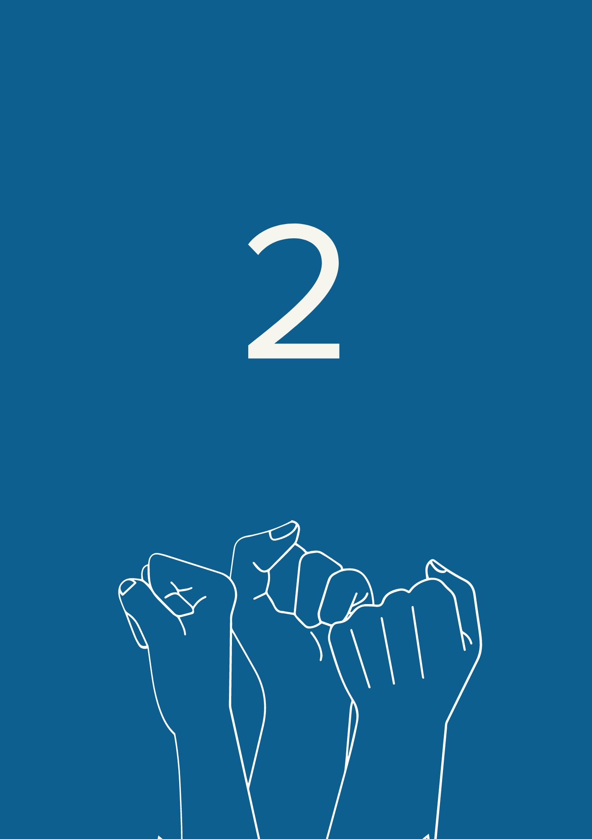

Empowerment

Empowering women and girls with disabilities is fundamental to uphold their human rights. It will ensure access to equal opportunities and be included in society without discrimination based on disability, gender or other additional factors.
We call on the European Union and national policymakers to:

Discrimination and inequality
Recognise the fact that women and girls with disabilities face systemic marginalisation and attitudinal and environmental barriers. These lead to lower economic and social status, increased risk of violence and abuse, intersectional discrimination, and barriers to accessing education and health care, including sexual and reproductive health. Barriers to accessing timely disability diagnosis and assessment, information, services, and justice, as well as civic and political participation, also exist. This hinders their active participation in society.
Recognise the need to overcome inequality and discrimination against women and girls with disabilities via strategies for empowerment. There should be a framework to ensure their full and effective participation in society, including through European and national gender strategies and disability strategies, and their respective implementation.
Ensure that all gender-related policies consider the negative impacts of, at least, the two discriminating factors of gender and disability. Disability interacts with physical and social barriers, negative attitudes, stigma, limited decision-making power, and lack of support services, among others. In addition, gender-based discrimination might result in rigid norms and roles, structural inequalities, and negative attitudes and social norms. This negative effect might be multiplied when it intersects with other factors such as ethnicity, age, sexual orientation and economic status.
Adopt specific measures to fulfil the rights enshrined in the UN Convention on the Rights of Persons with Disabilities for those women with disabilities at higher risk of exclusion. These include women and girls with disabilities residing in segregating institutions, women with multiple disabilities, women with complex support needs, women with intellectual and psychosocial disabilities, and women with rare diseases and/or with invisible disabilities.
Support combating ableism in social situations and media. Women and girls with disabilities are among those who are impacted by ableism the most. Ableism is a form of oppression that arises from systematically evaluating people’s competences, bodies and minds based on societally constructed ideas of normality, intelligence, desirability, and productivity. 175 (37.1%) participants of the survey recognised ableism as an oppressive factor in their lives.

Accessibility
Guarantee equal access to environments and information for women and girls with all forms of disabilities. Access to public transportation, buildings, and environments, as well as access to digital and non-digital information, is the first and foremost requirement for independent living. Adequate and free assistive technology and interpretation for sign language users are also crucial.
According to the survey, 46.8% of women with disabilities had difficulties accessing public buildings, and 38.6% of the participants found public transportation services inaccessible.
Improve the overall level of accessibility of communications, including digital tools, documents, and in-person communications. This must be done in collaboration with organisations of persons with disabilities and accessibility professionals, and by complying with EU-harmonised accessibility legislation. All national sign languages must be recognised, and easy-to-read versions of laws and policies must be made available.

Inclusion in the field of gender equality
Support a disability-inclusive approach to gender equality and women empowerment. By including the specific concerns of women and girls with disabilities in key strategic documents, including the EU Gender Action Plan III and in the implementation of the EU Gender Equality Strategy, the human rights and socio-economic outcomes for women and girls with disabilities will be improved.

Awareness-raising
Ensure campaignsto raise the awareness of women and girls with disabilities about their rights. Organisations of women with disabilities should take the lead on these campaigns. Awareness-raising can be delivered via inclusive and accessible training programmes, establishing decision-making bodies and committees led by women with disabilities, and adequate budget allocation. Awareness raising on violence, accessing justice, social rights, the right to political and civic participation, and sexual and reproductive health and rights, are among the crucial areas that must be considered in all plans of action.
Ensure campaigns to raise awareness within society about the rights and human dignity of women and girls with disabilities. Any form of stigma, stereotype, discrimination and prejudice on the basis of gender and disability is unacceptable. Healthcare professionals, professionals working within the justice system, and professionals working in education must be at the forefront to receive proper training on how to treat women and girls with disabilities with respect and equality.

Equal recognition before the law
Ensure women and girls with disabilities are recognised before the law on an equal basis with others.
The UN Committee on the Rights of Persons with Disabilities reported that certain jurisdictions have higher rates of imposing substitute decision-making on women than men. Therefore, it is particularly important to reaffirm that the legal capacity of women with disabilities should be recognised on an equal basis with others.
Guarantee that women and girls with disabilities can exercise their legal capacity. They must be able to make decisions about different aspects of their life, including retaining their fertility, their right to motherhood, establishing relationships, owning and inheriting properties and assets, retaining their right to work if they so wish, and controlling their own finances.

Independent living and inclusion in the community
Develop community-based support and services for women and girls with disabilities instead of institutionalising them. All the infrastructures for housing, education, healthcare, and other services must be developed in an accessible manner so that women and girls with disabilities can avail of mainstream services. It should be noted that traditional care models lead to loss of autonomy, economic disempowerment, and segregation and isolation of women and girls with disabilities from the rest of the community in institutions or family homes.
Promote community-based services as a human rights-based approach which supports women with disabilities and mothers of children with disabilities. Traditional care models impose a disproportionate burden of unpaid care work on family members, particularly women. Women with disabilities also act as carers to many family members with and without disabilities.

Health and rehabilitation
Guarantee women and girls with disabilities get access to the highest attainable standard of healthcare, including access to sexual and reproductive health, and mental health services. Gender and disability indicators must be included in health-related studies to avoid any inequality. 72% of the survey participants clarified that they need to receive medical services on a regular basis because of their disabilities. Sexism in the medical sector, including the dominance of masculine standards in healthcare systems, puts the life of many women with disabilities at risk.
Develop financial accessibility of healthcare by guaranteeing that people with disabilities will be able to pay for disability-related out-of-pocket healthcare expenditures and transport costs to access establishments and facilities that meet their needs. According to the survey, 46.6% of the participants had difficulties accessing medical services. The rate for difficulties in accessing medication is 38.6%.
Provide adequate healthcare support and consultation services for mothers of children with disabilities and those who are living with disabilities themselves. Mothers and carers of children with disabilities often have problems accessing appropriate hospitals and medication. Of 130 mothers of children with disabilities who participated in the survey, only 16 regularly have access to free and specific support and services.
Provide sufficient medical and paramedical teams trained in disability issues. We highlight that many women and girls with disabilities have been subjected to a lack of timely recognition of their disability. Women with intellectual disabilities and women with invisible disabilities are among those who suffer the most from a late recognition of their disability. Because of this, they do not get access to necessary support.
We point out that there is a high rate of ableist language against women and girls with disabilities used by healthcare practitioners. 42% of the survey participants pointed out the lack of healthy and non-biased communication with medical staff as an issue.

Inclusive education
Ensure inclusive education for girls and women with disabilities in an equal and accessible manner. This would also benefit equal opportunities and rights in other areas, including in the job market and political sphere.
Provide the means to access inclusive education so that it no longer depends solely on the personal investment of parents and teachers.
Finance initial and ongoing teacher training and provision of support professionals within schools in a way that addresses the specific needs of female students with disabilities. This should be focused on the gender specificities of living with disability. It should also focus on recognition and respect for the rights of women and girls with disabilities, and promote efficient actions to eradicate existing stereotypes against them.
Guarantee the equal education of women and girls with disabilities on technology and digital solutions in an accessible manner. In today’s technological age, it is critical to include women and girls with disabilities in accessible technology training programmes and to enhance universal design in products. Access to technology for women and girls with disabilities must be considered as a key factor to independent living and self-autonomy. The survey shows that 29.1% of the participants have difficulties accessing information online. Because of a lack of access to special training on digital accessibility, many women and girls with disabilities do not use digital environments.

Data gathering and research
Collect EU-wide disaggregated data by type of disability, gender, age, country or region, and area (rural or urban) to assess the impact of EU policies and programmes.
Carry out studies specific to women with disabilities to better inform their situation and find responses adapted to their needs.
Support and fund organisations of persons with disabilities to gather their own data and statistics, including on the situation of women and girls with disabilities.
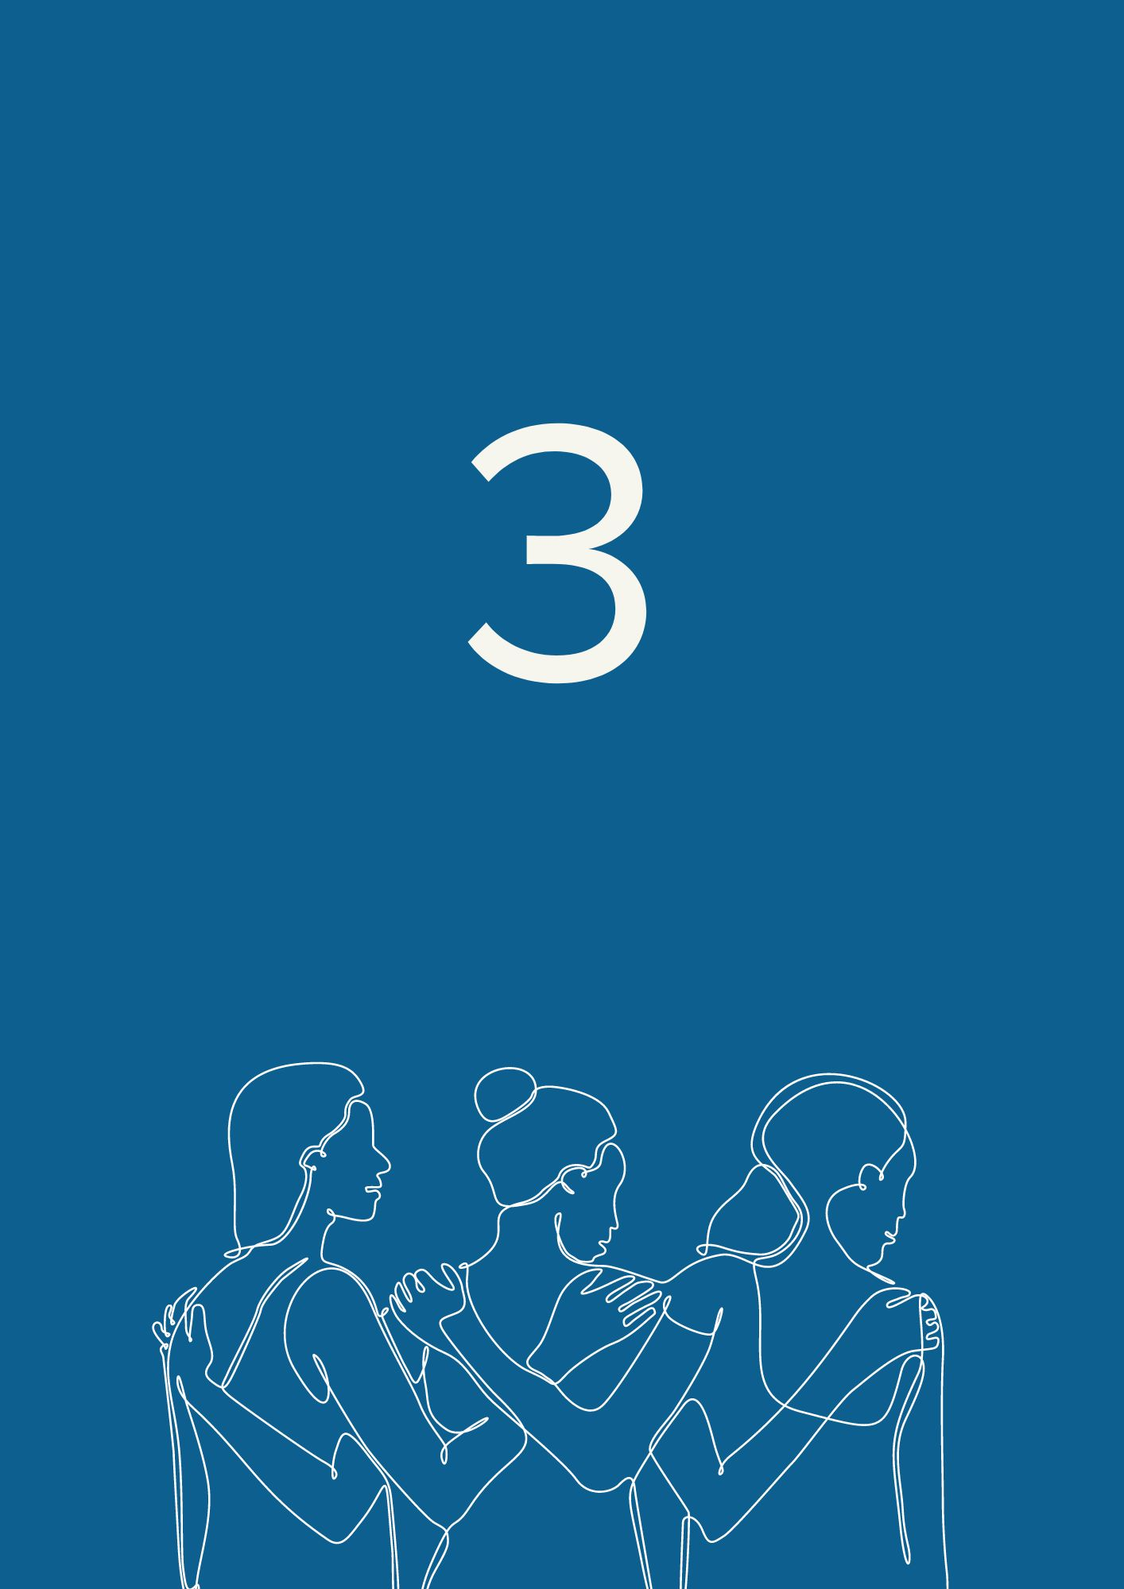

Leadership

Leadership is how women and girls with disabilities can lead their lives as independent persons, benefit from their rights in society and make their own decisions. Women with disabilities are key actors not only in their own lives but also in society.
We call on the European Union and national policymakers to:

Bodily autonomy
Guarantee the bodily autonomy of women and girls with disabilities as a prerequisite to their leadership. Women with disabilities need to have the capacity to exercise the fundamental concepts of power, free choice, and dignity – and have complete control of their body and access to it. Forced sterilisation, child marriage, lack of comprehensive sexuality education, and self-limiting social norms are among the consequences of violation of bodily autonomy and integrity of the person.
Criminalise practising forced sterilisation and forced abortion against women and girls with disabilities in all European countries. Forced sterilisation is still authorised in at least 13 EU Member States for people deprived of their legal capacity. Forced sterilisation constitutes a form of exploitation of the sexual and reproductive rights of women, and can lead to further sexual exploitation, especially of women living in institutions. When forced sterilisation is not classed as a distinct offence, it may be used to avoid potential criminal prosecution for third parties that either gave their consent or performed it.

Access to justice
Establish special mechanisms for compensation and reparations for women and girls with disabilities who were subjected to any form of violence. In many of the EU member states, there is a gap in access to justice and redress for persons with disabilities who are survivors of violence. Mechanisms must be established and implemented to process applications for compensation. Application procedures must be accessible and secure for women and girls with disabilities. It is also crucial to provide training on disability rights, including as part of the European Judicial training strategy.
Ensure the adoption and implementation of the EU Directive on combating violence against women and domestic violence, through the lens of gender and disability.
Provide resources for the swift implementation of the Council of Europe Convention on preventing and combating violence against women and domestic violence (“Istanbul Convention”) and its ratification by European countries that have not yet acceded to the Convention.

Reproductive rights and right to family life
Guarantee the highest attainable standards of sexual and reproductive healthcare for all women with disabilities. It must be done in a way that covers their needs, and fulfils their wishes in a respectful manner. The right to sexual and reproductive healthcare entails the right to make one’s own decisions freely and responsibly, and to get access to the related services and equipment. Lack of gynaecological care and access to safe abortion are among the main challenges for women with disabilities when exercising their reproductive health and rights.
Support the right of women with disabilities to form a family and their equal right to marriage, motherhood, including by adoption, and relationships.

Work and employment
Ensure equal employment opportunities for women with disabilities in a way that recognises and addresses root causes for inequality. Unemployment may lead to poverty and social exclusion. According to the available data, only 48.3% of women with disabilities are in employment in Europe. Only 24% of women with disabilities work full-time.
Establish a Disability Employment and Skills Guarantee, in line with the successful Youth Guarantee, to provide funding and support to ensure that women with disabilities have equal access to mainstream education, training and employment opportunities, including self-employment and entrepreneurship.
Ensure a quality work environment for women with disabilities. Behind employment data, the reality of the quality of employment that women with disabilities find is often obscured, and employees with disabilities are faced with discrimination at work. Some of the issues that women with disabilities experience include lack of reasonable accommodation, lack of access to assistive technology, insufficient salary, and curtailing of working hours, which can impede their right to a just retirement plan. Gender and disability pay gaps compound to create a situation where women with disabilities do not receive equal pay for equal work. In addition, sometimes it is not possible to keep disability allowances while working, or the amount is reduced. In our survey, respondents in Central and Eastern Europe were more affected by this issue.
Guarantee a secure work balance for mothers of children with disabilities who live with and without disabilities. Because of the lack of social support in many countries, mothers of children with disabilities take the responsibility of caring for the family. They should have enough support to work part or full time if they wish so.

Civil and political participation
Guarantee the participation of women with disabilities in political and public life by facilitating their involvement in all public decision-making. This must be ensured by implementing accessibility features, reasonable accommodation, eliminating violence against women in elections, including harassment, and awareness-raising within society. Women with disabilities should have the proper and necessary support to run as candidates and be politicians at all levels. We need to see more women with disabilities on top of electoral lists and in our parliaments.
Support the replacement of substituted decision-making regimes depriving persons with disabilities of their legal capacity with well-resourced supported decision-making schemes.

Governance and organisations of women with disabilities
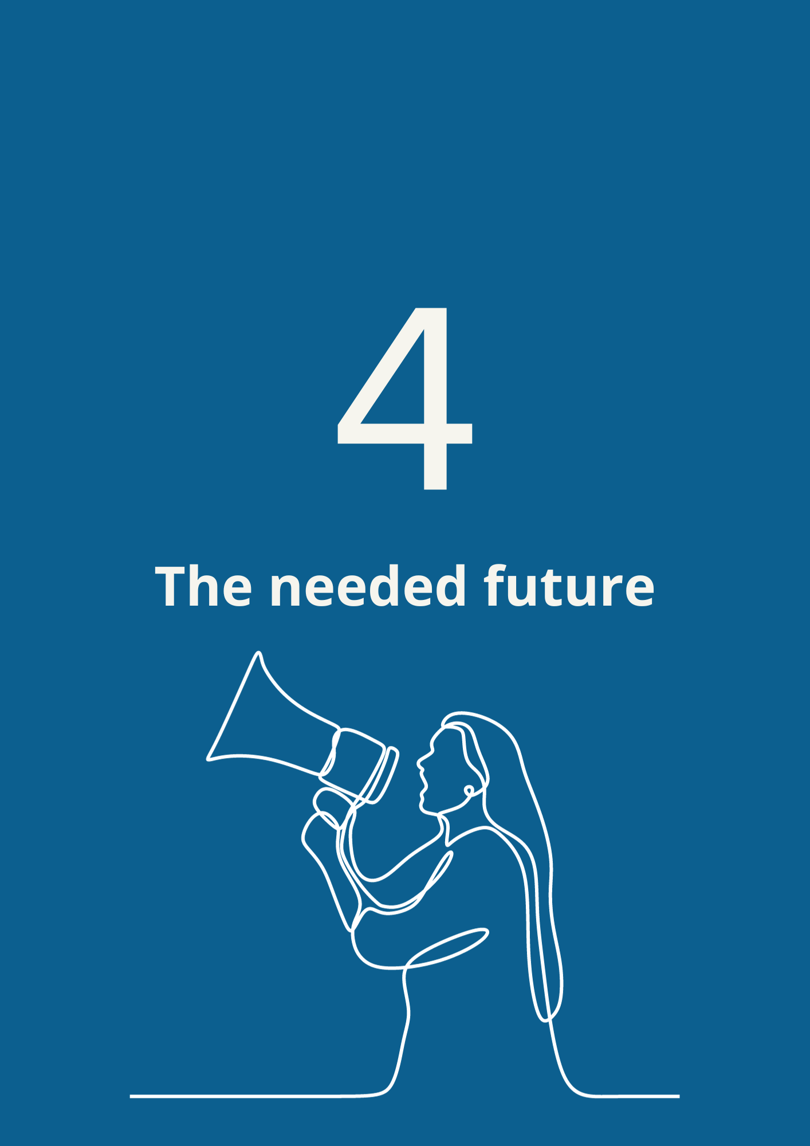
Guarantee the involvement of representative organisations of persons with disabilities, including of women with disabilities, in all disability-related affairs and gender mainstreaming programmes. When consulting organisations of persons with disabilities, policymakers should ensure such organisations consider the concerns and opinions of women with disabilities, and that women with disabilities have a seat at the table.
Meaningfully consult organisations of women with disabilities in the design and implementation of social services, public infrastructures, and civil protection systems.
Prioritise funding for representative organisations of women with disabilities in a way that they can contribute to equal opportunities for women and girls with disabilities. Also, it is important to encourage women’s rights organisations to include a disability lens in all their work and processes.
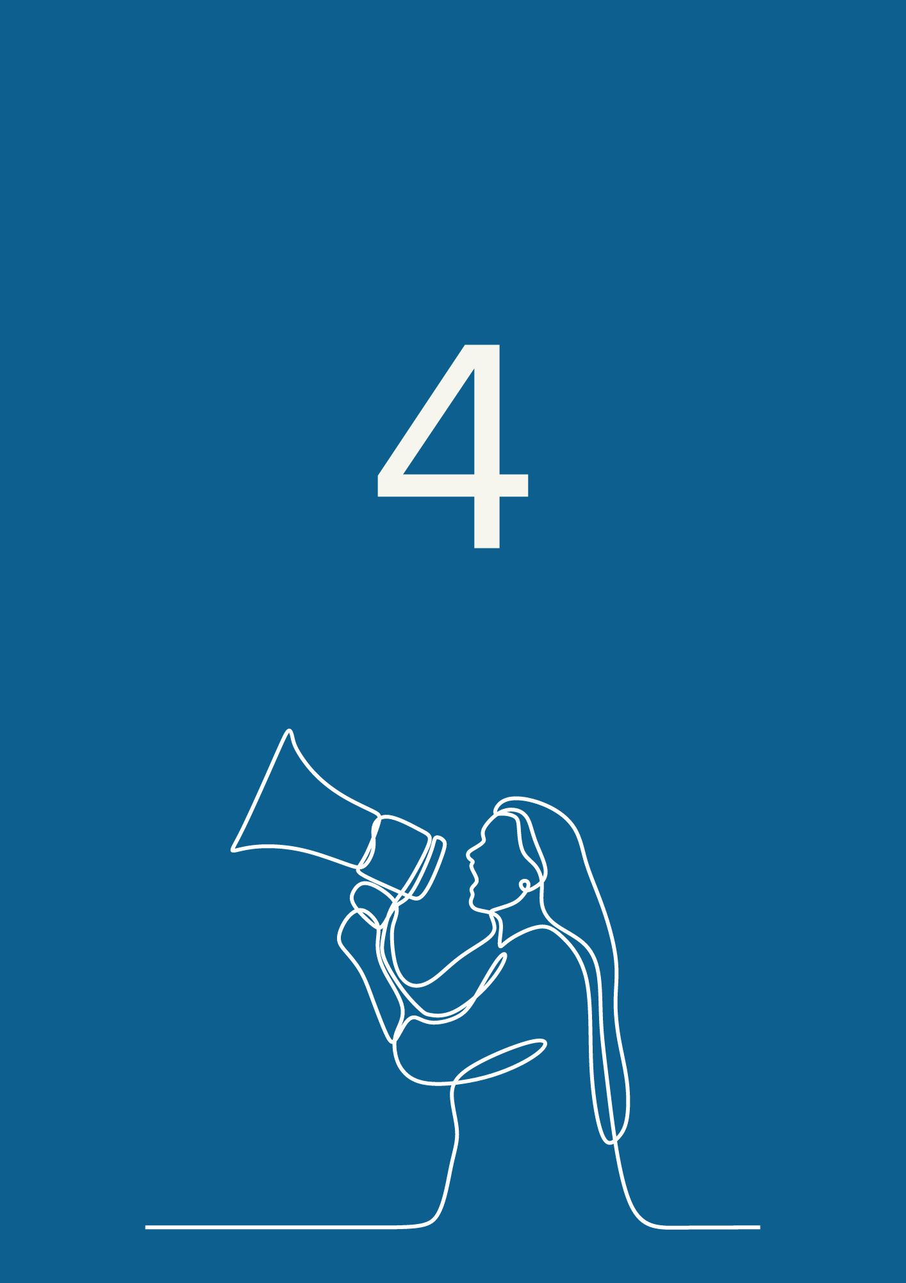

The needed future

Every woman and girl with disabilities shall be treated and accepted with the deserved human dignity and respect.
We call for a future where the diverse experiences of all women and girls with disabilities enrich our societies.
We call on all the feminism movements to strengthen their actions by welcoming the diverse experiences of women with disabilities.
A future where we work together to ensure all women and girls with disabilities live in peace, in a just world where they are safe and secure.
Ahead of the 2024 European elections, we demand from the European Union and our governments:
- The full participation of women with disabilities as voters and as candidates for all elections – including for the European Parliament, and at national and local levels.
- Meaningful inclusion and leadership in decision-making, including by enhancing accessibility measures for the participation of women and girls with disabilities in all issues.
- Increased visibility and awareness of and for women and girls with disabilities. The rights of women and girls with disabilities should be mainstreamed and visible in the work of the European Union and across Europe.
- Concrete targeted actions to reduce the poverty level faced by women with disabilities, including through equal employment and pay measures, and ensuring the amount of disability allowances received by women and girls with disabilities is kept regardless of employment status or the financial means of their partners and families.
- Adoption of the EU Directive on combating violence against women and the end of forced sterilisation of women and girls with disabilities across Europe.
- Funding of organisations and projects that support the empowerment, leadership and improvement of rights of women and girls with disabilities.
Nothing without women and girls with disabilities.

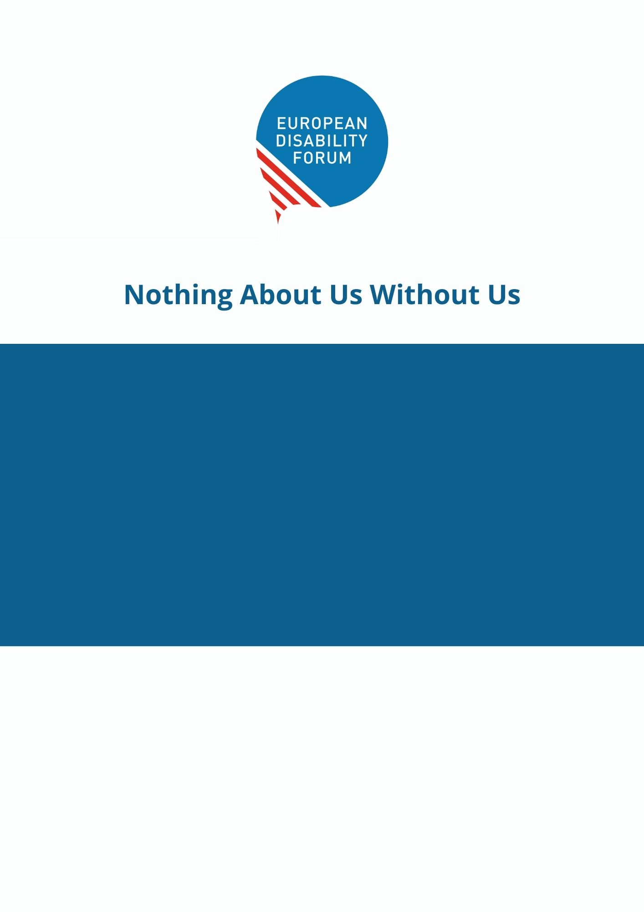
Third Manifesto on the
Rights of Women and Girls with Disabilities
in the European Union
The European Disability Forum
7-8 Avenue des Arts
1210 Brussels - Belgium
info@edf-feph.org
www.edf-feph.org
Follow us on social media!

EU-SILC UDB release 1, 2021. Data available in European comparative data on Europe 2020 and persons with disabilities (December 2021), page 19.
CRPD Committee, General Comment no 3 on women and girls with disabilities, paragraph 5.

